January 18th, 2015

ASP.NET 5 and AngularJS Part 5, Form Validation
http://stephenwalther.com/archive/2015/01/18/asp-net-5-and-angularjs-part-5-form-validation
This is the fifth part in a multiple part blog series on building ASP.NET 5 (ASP.NET vNext) apps with AngularJS. In this series of blog posts, I show how you can create a simple Movie app using ASP.NET 5, MVC 6, and AngularJS.
- ASP.NET 5 and AngularJS Part 1, Grunt, Uglify, and AngularJS
- ASP.NET 5 and AngularJS Part 2, Using the MVC 6 Web API
- ASP.NET 5 and AngularJS Part 3, Adding Client Routing
- ASP.NET 5 and AngularJS Part 4, Using Entity Framework 7
- ASP.NET 5 and AngularJS Part 5, Form Validation
- ASP.NET 5 and AngularJS Part 6, Security
- ASP.NET 5 and AngularJS Part 7, Running on a Mac
You can download the code discussed in this blog post from GitHub:
https://github.com/StephenWalther/MovieAngularJSApp
In this blog post, I explain how to implement both client-side and server-side form validation.

Client-Side Validation
Let’s start with the client-side validation. We’ll use the built-in features of AngularJS to validate the movie add and edit forms.
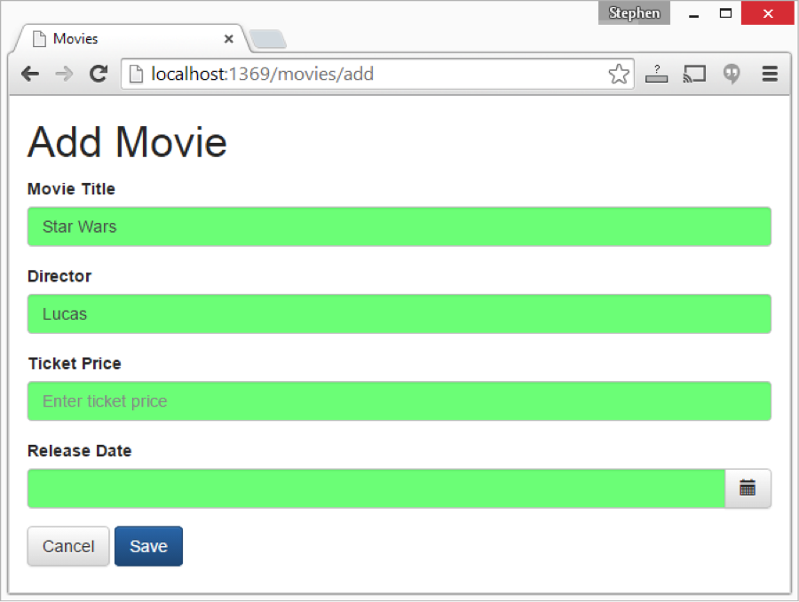
Here’s the add.html page:
<h1>Add Movie</h1>
<div class="row">
<div class="col-md-5">
<form name="formAdd" novalidate ng-submit="add()">
<ng-include src="'/partials/_edit.html'"></ng-include>
<a href="/" class="btn btn-default">Cancel</a>
<button type="submit" ng-disabled="formAdd.$invalid" class="btn btn-primary">Save</button>
</form>
</div>
</div>
And, here’s the edit.html page:
<h1>Edit Movie</h1>
<div class="row">
<div class="col-md-5">
<form name="formEdit" novalidate ng-submit="edit()">
<ng-include src="'/partials/_edit.html'"></ng-include>
<a href="/" class="btn btn-default">Cancel</a>
<button type="submit" ng-disabled="formAdd.$invalid" class="btn btn-primary">Save</button>
</form>
</div>
</div>
The add and edit forms contain the FORM element and the BUTTON elements for the forms. The FORM element includes a novalidate attribute that disables HTML5 validation. This is necessary because the HTML5 validation attributes conflict with the AngularJS validation directives.
Notice that the BUTTON element includes an ng-disabled directive. This directive is used to prevent a user from submitting the form when there are any client-side validation errors.
You’ll notice that both forms use the ng-include directive to include a partial named _edit.html. The _edit.html contains the actual form fields.
<div class="bg-danger validationErrors" ng-show="validationErrors">
<ul>
<li ng-repeat="error in validationErrors">{{error}}</li>
</ul>
</div>
<div class="form-group">
<label for="Title">Movie Title</label>
<input name="Title"
type="text"
class="form-control"
placeholder="Enter title"
ng-model="movie.Title"
ng-required="true"
ng-minlength="3" />
</div>
<div class="form-group">
<label for="Director">Director</label>
<input name="Director"
type="text"
class="form-control"
placeholder="Enter director"
ng-model="movie.Director"
ng-required="true" />
</div>
<div class="form-group">
<label for="TicketPrice">Ticket Price</label>
<input name="TicketPrice"
type="text"
class="form-control"
placeholder="Enter ticket price"
ng-model="movie.TicketPrice">
</div>
<div class="form-group">
<label for="Release">Release Date</label>
<p class="input-group" ng-controller="DatePickerController">
<input type="text"
class="form-control"
datepicker-popup
ng-model="movie.ReleaseDate"
is-open="opened" />
<span class="input-group-btn">
<button type="button"
class="btn btn-default"
ng-click="open($event)">
<i class="glyphicon glyphicon-calendar"></i>
</button>
</span>
</p>
</div>
The _edit.html form contains fields for the movie Title, Director, Ticket Price and Release Date. AngularJS directives are used to perform the following validation:
- Title – Required, Must be at least 3 characters.
- Director – Required.
- TicketPrice – Required.
If validation fails, then the ng-invalid CSS class is applied to the field and the field appears with a red background.
input.ng-invalid.ng-touched {
background-color: #FA787E;
}
input.ng-valid.ng-touched {
background-color: #78FA89;
}
I ran into one minor wrinkle when I created the _edit.html partial. When the partial was requested from the server, the web.config file that I created in part 3 of this blog series redirected the request to the index.html page and I got an infinite regression. To flatten this wrinkle, I had to exclude the /partials/ folder from the path rewrite.
<!-- from http://stackoverflow.com/questions/25916851/wrapping-staticfilemiddleware-to-redirect-404-errors -->
<configuration>
<system.webServer>
<modules runAllManagedModulesForAllRequests="true" />
<rewrite>
<rules>
<!--Redirect selected traffic to index -->
<rule name="Index Rule" stopProcessing="true">
<match url=".*" />
<conditions logicalGrouping="MatchAll">
<add input="{REQUEST_FILENAME}" matchType="IsFile" negate="true" />
<add input="{REQUEST_URI}" matchType="Pattern" pattern="^/api/" negate="true" />
<add input="{REQUEST_URI}" matchType="Pattern" pattern="^/partials/" negate="true" />
</conditions>
<action type="Rewrite" url="/index.html" />
</rule>
</rules>
</rewrite>
</system.webServer>
</configuration>

Updating the Movie Model
Client-side validation is only one half of the validation story. The other half of validation is handled by the ASP.NET 5 framework.
Here’s what the updated Movie model looks like:
using System;
using System.ComponentModel.DataAnnotations;
namespace MovieAngularJSApp.Models
{
public class Movie
{
public int Id { get; set; }
[Required(ErrorMessage="Movie Title is Required")]
[MinLength(3, ErrorMessage="Movie Title must be at least 3 characters")]
public string Title { get; set; }
[Required(ErrorMessage = "Movie Director is Required.")]
public string Director { get; set; }
[Range(0, 100, ErrorMessage ="Ticket price must be between 0 and 100 dollars.")]
public decimal TicketPrice { get; set; }
[Required(ErrorMessage="Movie Release Date is required")]
public DateTime ReleaseDate { get; set; }
}
}
Notice that validation attributes are applied to the properties of the Movies model. For example, the [Required] and [MinLength] attributes are applied to the Title property.

Updating the Movies Database
Because I made changes to the Movie model, I need to update the database to match the new model. I opened up a Command Prompt, navigated to the project folder and ran the following two commands:
k ef migration add movieProps
k ef migration apply
Unfortunately, the second command threw an exception because I was trying to add a DateTime column to the existing Movies database table. Because the table already contains data, I got the exception.
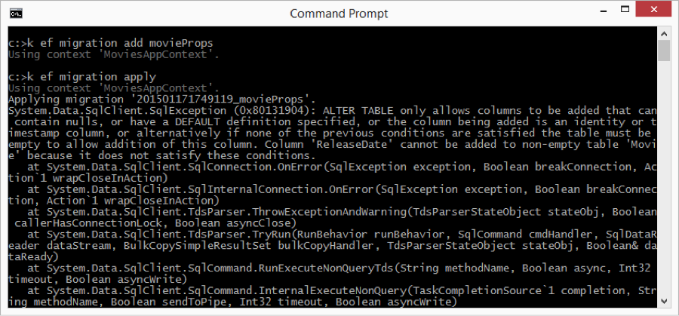
The easiest fix for this issue is to drop the database. I found the MoviesDatabase.mdf and MoviesDatabase_log.ldf in my c:\users\stephen folder and deleted the two files. When I ran the k ef migration apply command again, everything worked fine.
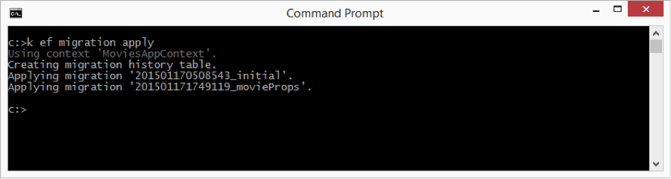

Updating the Server Controller
The next step is to update the Web API controller on the server. The modified MoviesController looks like this:
using System;
using System.Collections.Generic;
using System.Linq;
using Microsoft.AspNet.Mvc;
using MovieAngularJSApp.Models;
namespace MovieAngularJSApp.API.Controllers
{
[Route("api/[controller]")]
public class MoviesController : Controller
{
private readonly MoviesAppContext _dbContext;
public MoviesController(MoviesAppContext dbContext)
{
_dbContext = dbContext;
}
[HttpGet]
public IEnumerable<Movie> Get()
{
return _dbContext.Movies;
}
[HttpGet("{id:int}")]
public IActionResult Get(int id)
{
var movie = _dbContext.Movies.FirstOrDefault(m => m.Id == id);
if (movie == null) {
return new HttpNotFoundResult();
} else {
return new ObjectResult(movie);
}
}

[HttpPost]
public IActionResult Post([FromBody]Movie movie)
{
if (ModelState.IsValid)
{
if (movie.Id == 0)
{
_dbContext.Movies.Add(movie);
_dbContext.SaveChanges();
return new ObjectResult(movie);
}
else
{
var original = _dbContext.Movies.FirstOrDefault(m => m.Id == movie.Id);
original.Title = movie.Title;
original.Director = movie.Director;
original.TicketPrice = movie.TicketPrice;
original.ReleaseDate = movie.ReleaseDate;
_dbContext.SaveChanges();
return new ObjectResult(original);
}
}
return new BadRequestObjectResult(ModelState);

}

[HttpDelete("{id:int}")]
public IActionResult Delete(int id)
{
var movie = _dbContext.Movies.FirstOrDefault(m => m.Id == id);
_dbContext.Movies.Remove(movie);
_dbContext.SaveChanges();
return new HttpStatusCodeResult(200);
}

}
}
Notice that the Post() method (called by both the Add and Edit forms) checks ModelState. If ModelState is not valid then the following line of code is executed:
return new BadRequestObjectResult(ModelState);
The BadRequestObjectResult action result returns all of the validation error messages in ModelState to the client. The BadRequestObjectResult also returns a 400 Bad Request status code.
Here’s what the response looks like in Chrome Developer Tools:
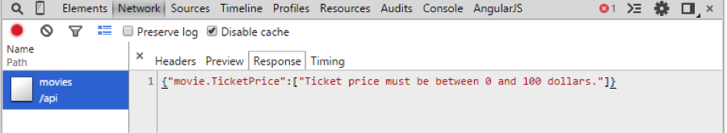
Be warned that the BadRequestObjectResult is not included in Beta 2 of the ASP.NET 5 framework. You need to switch to Beta 3. I describe how to use the Nightly Builds of ASP.NET 5 in the following blog post:
http://stephenwalther.com/archive/2015/01/15/upgrading-visual-studio-2015-preview-to-asp-net-5mvc-6-rc

Updating the Client Controllers
The very final step is to update the client-side controllers to display any validation errors returned from the server.
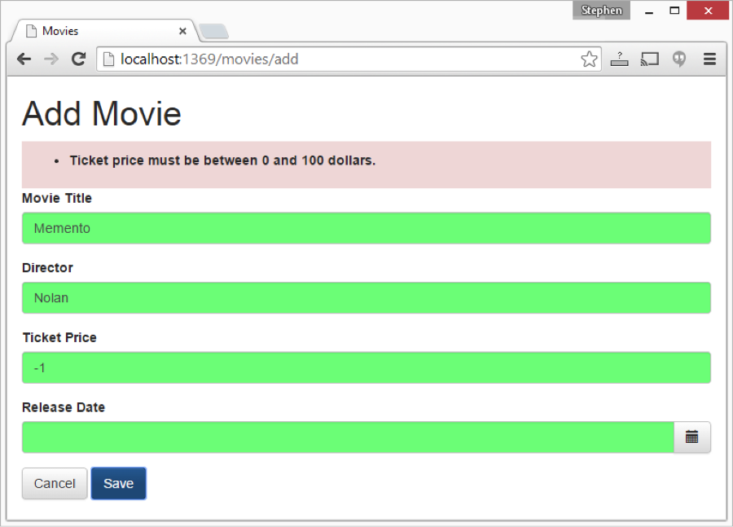
The moviesControllers.js file below contains updated MoviesAddController and MoviesEditController functions.
(function () {
'use strict';
angular
.module('moviesApp')
.controller('MoviesListController', MoviesListController)
.controller('MoviesAddController', MoviesAddController)
.controller('MoviesEditController', MoviesEditController)
.controller('MoviesDeleteController', MoviesDeleteController)
.controller('DatePickerController', DatePickerController);
/* Movies List Controller */
MoviesListController.$inject = ['$scope', 'Movie'];
function MoviesListController($scope, Movie) {
$scope.movies = Movie.query();
}

/* Movies Create Controller */
MoviesAddController.$inject = ['$scope', '$location', 'Movie'];
function MoviesAddController($scope, $location, Movie) {
$scope.movie = new Movie();
$scope.add = function () {
$scope.movie.$save(
// success
function () {
$location.path('/');
},
// error
function (error) {
_showValidationErrors($scope, error);
}
);
};
}

/* Movies Edit Controller */
MoviesEditController.$inject = ['$scope', '$routeParams', '$location', 'Movie'];

function MoviesEditController($scope, $routeParams, $location, Movie) {
$scope.movie = Movie.get({ id: $routeParams.id });
$scope.edit = function () {
$scope.movie.$save(
// success
function () {
$location.path('/');
},
// error
function (error) {
_showValidationErrors($scope, error);
}
);
};
}

/* Movies Delete Controller */
MoviesDeleteController.$inject = ['$scope', '$routeParams', '$location', 'Movie'];

function MoviesDeleteController($scope, $routeParams, $location, Movie) {
$scope.movie = Movie.get({ id: $routeParams.id });
$scope.remove = function () {
$scope.movie.$remove({id:$scope.movie.Id}, function () {
$location.path('/');
});
};
}

/* Movies Delete Controller */
DatePickerController.$inject = ['$scope'];
function DatePickerController($scope) {
$scope.open = function ($event) {
$event.preventDefault();
$event.stopPropagation();
$scope.opened = true;
};
}

/* Utility Functions */
function _showValidationErrors($scope, error) {
$scope.validationErrors = [];
if (error.data && angular.isObject(error.data)) {
for (var key in error.data) {
$scope.validationErrors.push(error.data[key][0]);
}
} else {
$scope.validationErrors.push('Could not add movie.');
};
}
})();
Notice that both the MoviesAddController and MoviesEditController functions now include an error callback. When a 400 Bad Request is returned from the server, the error callback is invoked and the _showValidationErrors() function is called.
The _showValidationErrors() function adds the error messages from ModelState to the $scope.validationErrors array. The contents of the validationErrors array is displayed in the _edit.html form:
<div class="bg-danger validationErrors" ng-show="validationErrors">
<ul>
<li ng-repeat="error in validationErrors">{{error}}</li>
</ul>
</div>

Summary
In this blog post, I focused on explaining how you can perform validation when using ASP.NET 5 and AngularJS. I explained how you can use AngularJS directives – such as the ng-required directive – to perform client-side validation. I also explained how you can take advantage of ModelState and the BadRequestObjectResult when validating data submitted to the ASP.NET Web API.

